# CUSTOMER CHURN ANALYSIS SQL QUERIES

**KPI’s**

**1. Customer churn by genders**

## SELECT Gender, COUNT (Gender) AS total_customers

## FROM churnanalysis_data

## WHERE Exited=1

## GROUP BY Gender

## ORDER BY total_customers desc;

Output:

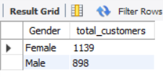

**2. Customer churn by Age groups**

SELECT

CASE

WHEN Age BETWEEN 18 AND 30 THEN '18-30'

WHEN Age BETWEEN 31 AND 50 THEN '31-50'

ELSE '51+'

END AS Age_Group,

COUNT (*) AS Total_Customers,

SUM(Exited) AS Churned_Customers

FROM

churnanalysis_data

WHERE Exited=1

Group by Age_Group

ORDER BY Churned_Customers;

Output:

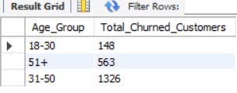

**3. Customer churn by Tenure**

SELECT

CASE

WHEN Tenure BETWEEN 0 AND 3 THEN '0-3 years'

WHEN Tenure BETWEEN 4 AND 7 THEN '4-7 years'

ELSE '8+ years'

END AS Tenure_group,

COUNT (*) AS Total_Curned_Customers

FROM

churnanalysis_data

WHERE Exited=1

GROUP BY Tenure_group

ORDER BY Total_Curned_Customers desc;

Output

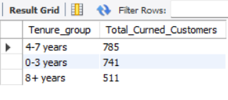

4. **Customer churn by geographical region**

SELECT Geography,

## COUNT (*) AS Total_Customers,

## ROUND((SUM(Exited) * 100.0 / COUNT (*)), 2) AS High_Churn_Rate

## FROM

## churnanalysis_data

## GROUP BY

## Geography

## ORDER BY

## High_Churn_Rate DESC

LIMIT 1;

Output:

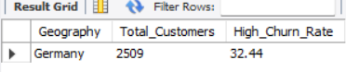

## 5. Churn Rate by product usage

SELECT   
 NumOfProducts,  
 COUNT (*) AS Total_Customers,  
 SUM(Exited) AS Churned_Customers  
FROM   
 churnanalysis_data  
GROUP BY   
 NumOfProducts  
ORDER BY   
 Churned_Customers DESC;

Output:

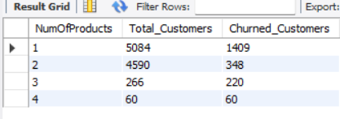

**6. Churn percentage by Active Members**

SELECT   
 ROUND((SUM(Exited) * 100.0 / COUNT (*)), 2) AS Percentage  
FROM   
 churnanalysis_data  
WHERE   
 IsActiveMember = 1;

Output

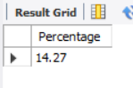

**7. Average balance of churned vs. retained customers**

SELECT   
 Exited AS Customer_Status,  
 COUNT (*) AS Total_Customers,  
 AVG(Balance) AS Average_Balance  
FROM   
 churnanalysis_data  
GROUP BY   
 Exited;

Output:

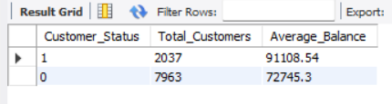

## 8. Average credit score of churned customers

SELECT   
 AVG(CreditScore) AS Average_Credit_Score_Churned_Customers  
FROM   
 churnanalysis_data  
WHERE   
 Exited = 1;

Output:

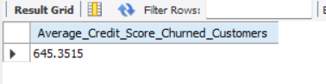

**9. customers Churn with a high balance**

SELECT COUNT (*) AS Total_customers

FROM churnanalysis_data

WHERE Exited=1 and Balance > 100000;

Output:

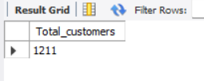

**10**. **Overall Churn rate in the dataset**

## SELECT ROUND(SUM(Exited) * 100.0 / COUNT (*), 2) AS Overall_Churn_Rate FROM churnanalysis_data;

Output:

